

User Manual
Scheduled Alert Module
www.flowhcm.com

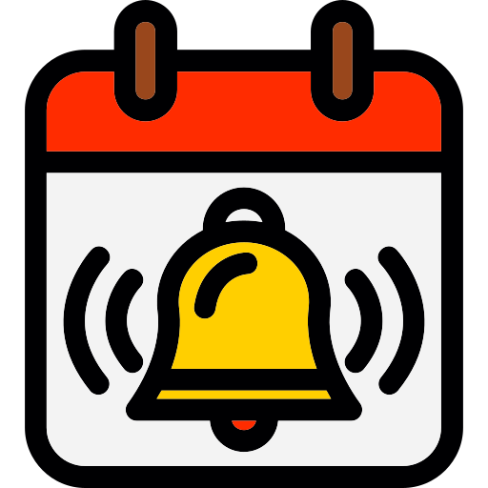

Table of Contents
Automated Alerts 3
STEP # 1: Alert Selection 5
STEP # 2: Employee Filtration 6
STEP # 3: Alert Recipients 7
STEP # 4: Alert Frequency 8
Automated Alert Settings 9

Automated Alerts

- Navigate to Others Tab and click on Scheduled Alert Module
- You can see the Automated Alert form
- To schedule an Alert, click on Add Automated Alert button
- The form shows Four (4) steps for input and criteria to schedule an alert
- Enter the required information in the fields
- Click on save button to schedule an alert

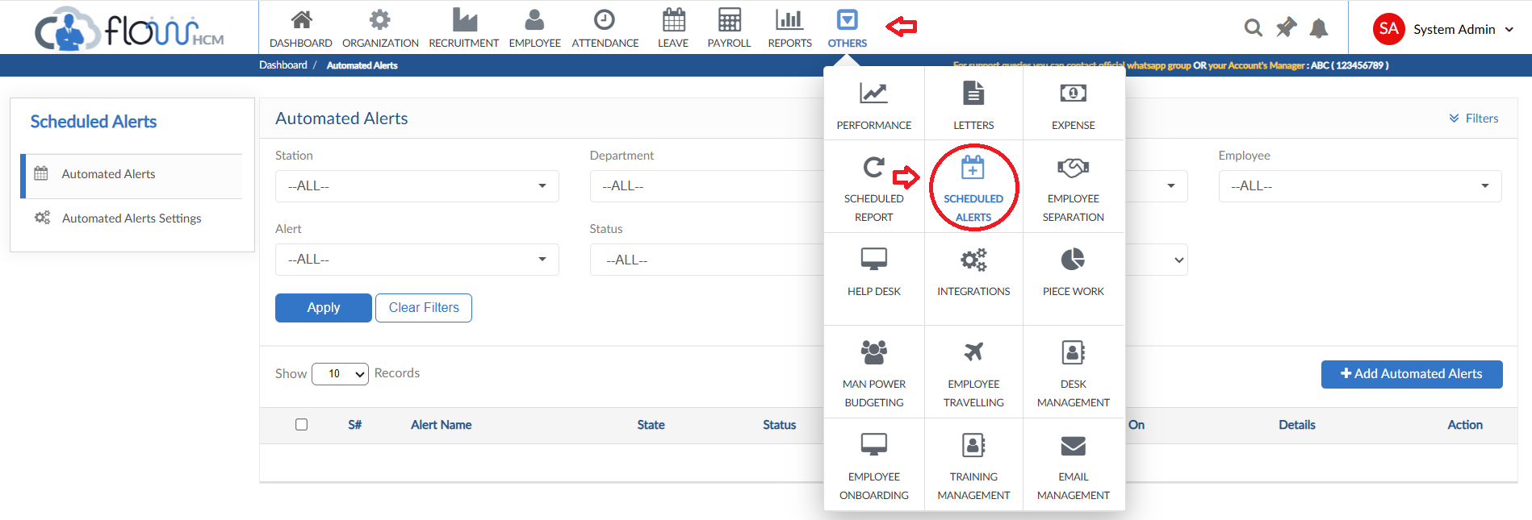
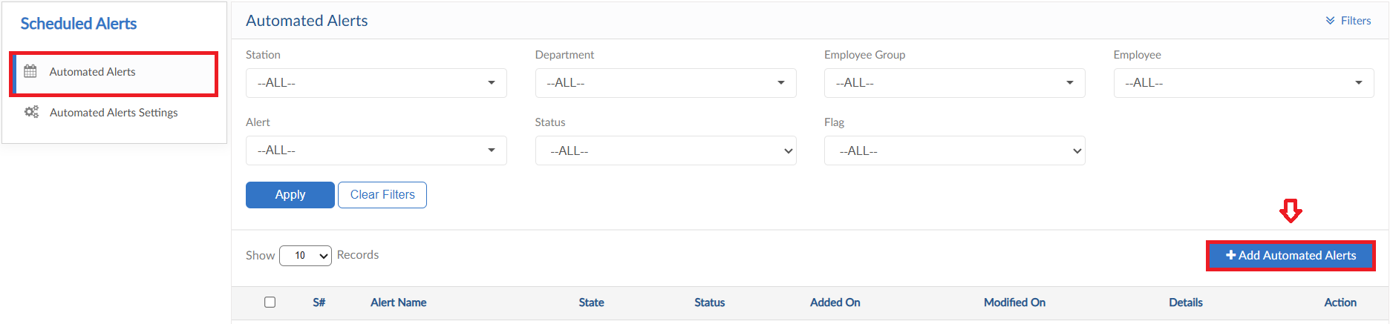
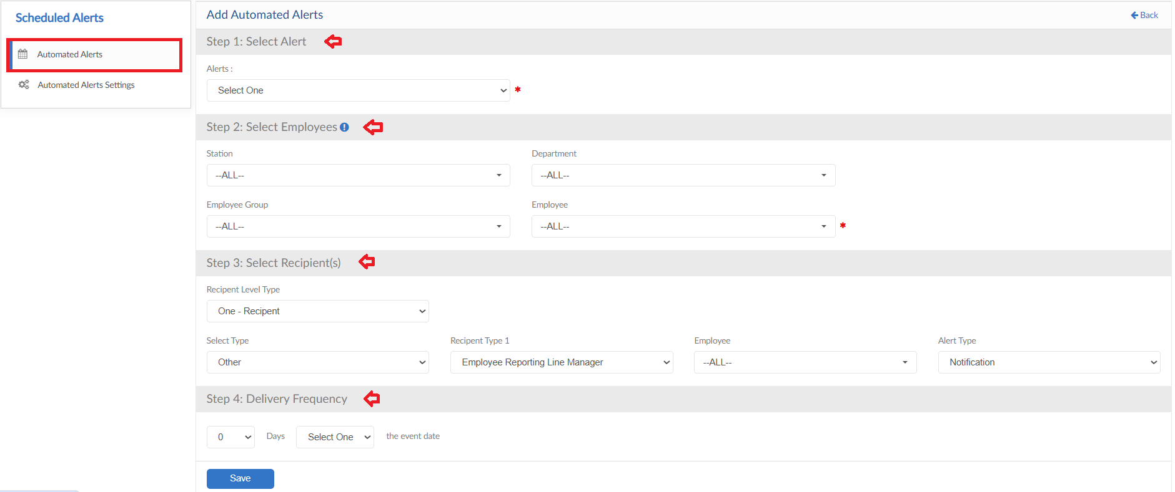

STEP # 1: Alert Selection

- First step is to select the alert required to schedule
- Alert dropdown shows list of multiple alerts
- Select any one alert and move forward to the next step
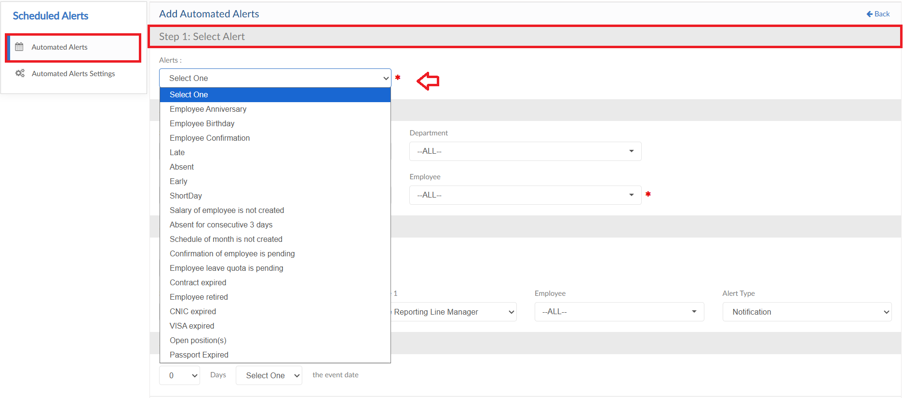

STEP # 2: Employee Filtration

- In this step, employee filter criteria will be applied whose data is required in the selected scheduled alert
- Through the filters available select the required employees mapping
- Select employees from the dropdown and move forward to the next step
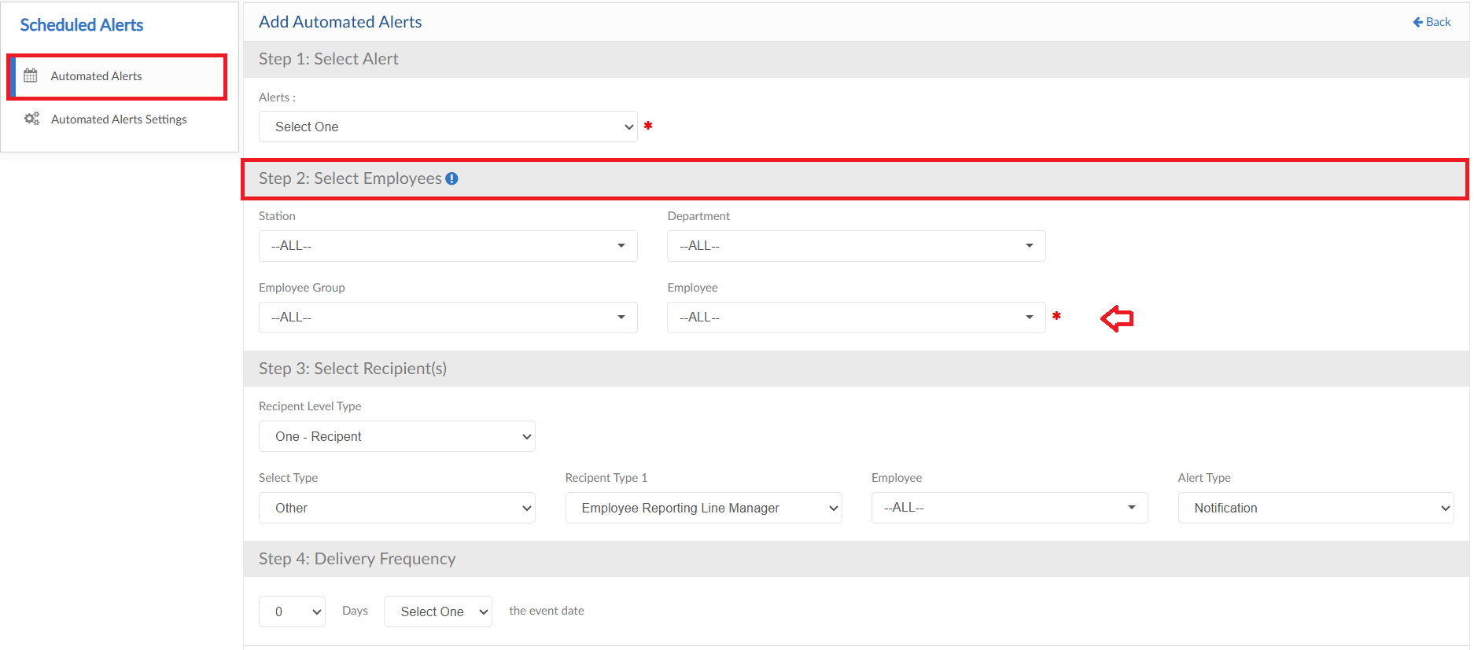

STEP # 3: Alert Recipients

- In this step, recipients for alert will be selected
- Select the Level and type from dropdowns
- Select Recipient type from dropdown and if required unselect employees from dropdown
- Select the alert type from dropdown to notify
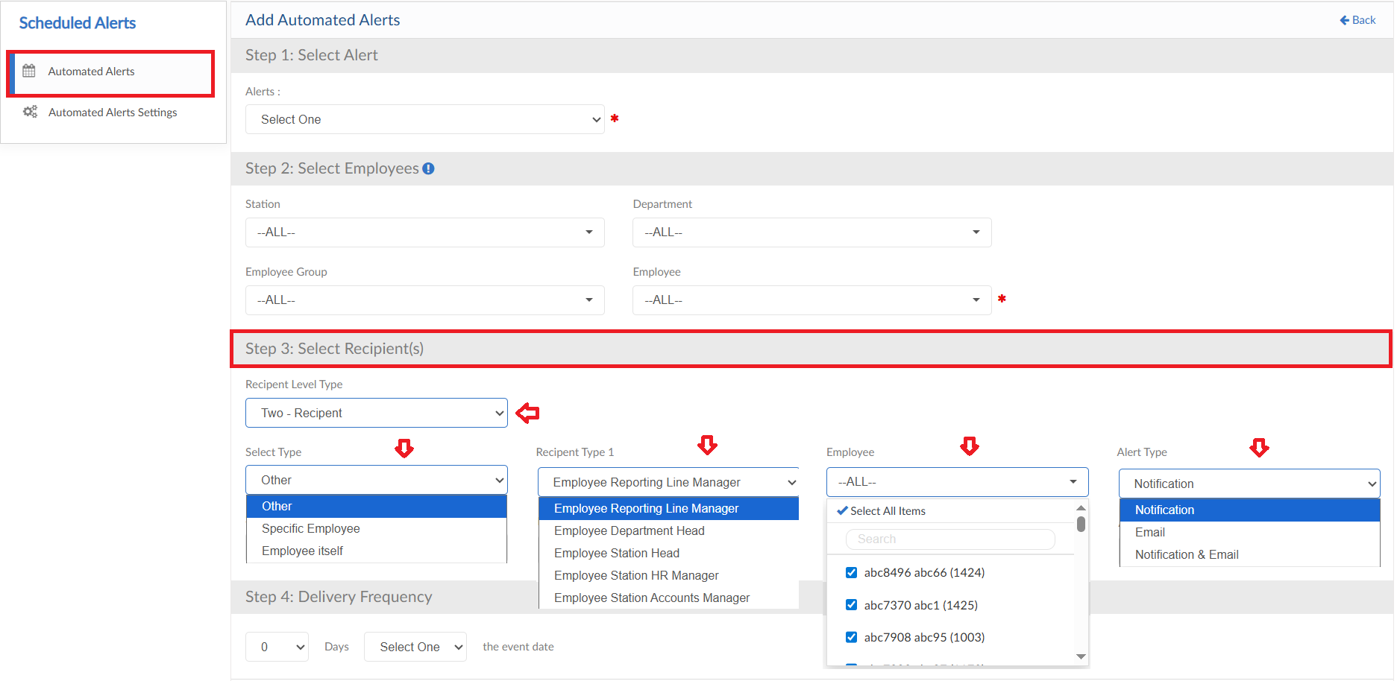

STEP # 4: Alert Frequency

- In this step, alert delivery frequency will be defined
- The frequency will work in a way
- Current = For the current day
- Before = Days will be defined as well then before so alert will be sent 2 days before the event
- After = Days will be defined as well then after so alert will be sent 2 days after the event
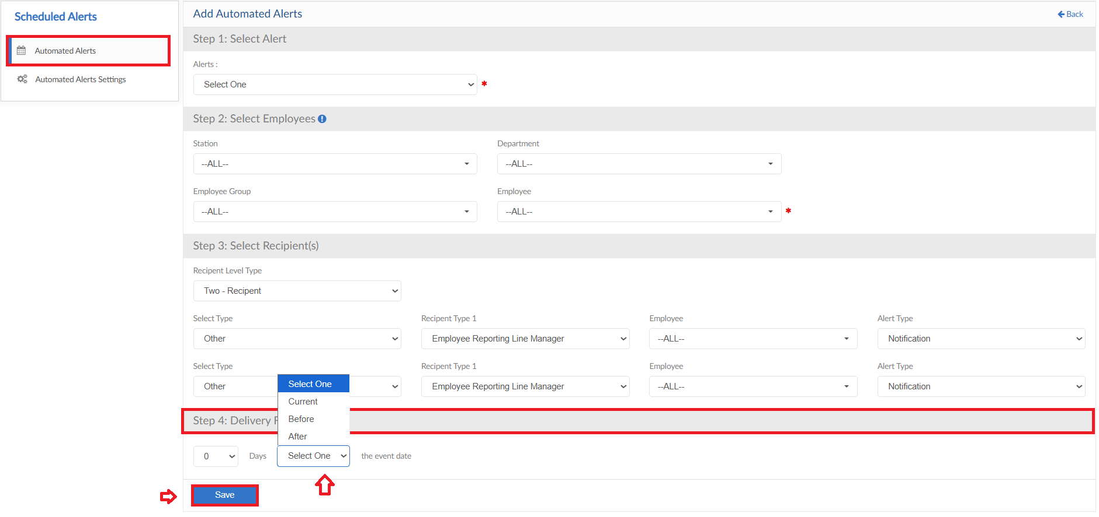

Automated Alert Settings

- Travel Setting form consists of single setup form
- Click on Automated Alert Settings form
- Select the Alert from dropdown and define the Subject for email
- Write the content for email and use the Insert field dropdown if required for auto data get from system
- Then click on Save button
